Reliant Global Health

**New Content**

**HOME**

BILLING PRECISION, CARE DELIVERED

Billing Solutions for Health Providers

Streamlining Healthcare Revenue with Expert Precision

Healthcare Financial Management

**VISION**

Empowering Healthcare Excellence Through Seamless Financial Management, In realizing our vision, We aspire to be the trusted partner that healthcare providers rely on for their financial management needs. Our dedication to integrity, accuracy, and ethical practices forms the foundation of this trust, ensuring that healthcare organizations can focus on their core mission with the utmost confidence in our services.

**MISION**

At Reliant Global Healthcare, our mission is to provide innovative and reliable medical billing solutions that optimize financial operations for healthcare providers worldwide. allowing healthcare professionals to focus on delivering exceptional patient care. Through cutting-edge technology, unwavering integrity, and a commitment to continuous improvement, we aim to be the leading partner in elevating healthcare financial management.

**VALUES**

At Reliant Global Healthcare, our values are the heart of our organization. We operate with unwavering integrity, ensuring honesty, transparency, and confidentiality in all our interactions. Social responsibility drives us to contribute to healthcare accessibility and equity. These values collectively steer us towards realizing our mission of empowering healthcare providers and achieving industry excellence.

**About US**

The World's Best Medical Billing Company. That You Can Trust

At Reliant Global Healthcare, our values are the heart of our organization. We operate with unwavering integrity, ensuring honesty, transparency, and confidentiality in all our interactions. Social responsibility drives us to contribute to healthcare accessibility and equity. These values collectively steer us towards realizing our mission of empowering healthcare providers and achieving industry excellence

Reliant Global Healthcare: Your Trusted Partner for Seamless Medical Billing Excellence." "Where Trust Meets Excellence in Healthcare Financial Management.

**About summary**

Bringing over 15 years of unwavering expertise to the realm of medical billing, Reliant Global Healthcare is your proven partner for precision and success. Our extensive experience fuels our commitment to delivering tailored solutions that streamline financial operations, allowing healthcare providers to shine in their core mission. Trust in our seasoned proficiency to navigate the complexities of medical billing while you focus on patient care.

**We've earned our place as award-winning authority in the field. Count on us for precision, transparency, and a proven track record.**

At Reliant Global Healthcare, we stand as certified and award-winning beacon of trust in the medical industry. Our commitment to excellence is recognized through our validating our expertise and adherence to the highest standards. With a legacy of achievement, including prestigious awards highlight our innovative approaches and dedication, contribute we offer a proven track record of success. Trust in our certified professionals who have consistently delivered exceptional medical billing solutions, team's extensive experience and deep industry knowledge contribute allowing healthcare providers to focus on what matters most – delivering outstanding patient care.

**Our Services**

Healthcare Financial Management At Reliant Global Healthcare,

Patient Registration

Patient Scheduling

Charge Entry

Coding

Patient Demographic

Eligibility Verification

Authorization

Payment Posting

AR & Denial Management

Patient Calling

Patient Statement & Hard collections

Provider Prior Credentialing

Credentialing Revalidation

Compliance & Audit

**Products**

Registration verification & co-pay collection

Insurance verification & coverage scan

Authorization management

Charge entry and coding

Claim scrub, issue resolution & submission

Posting and payments

Claim denials resolution

Zero pay & Insurance credit resolution

Patient refunds

Performance reporting and insights

**Service**

**Patient Demographics Entry (Patient Registration) Services**



At Reliant Global Healthcare, we have experienced & well trained staff of revenue cycle professionals to validate all information provided in the face-sheets & Medical Records. Our team contacts the provider's office or the medical billing company if any information is incomplete or erroneous in case of any discrepancies. Our team members enter the validated data on the client's practice management software with a high degree of accuracy and within a turnaround time of 24 hours.

Accurate Entry of patient information results in timely reimbursements and reduces the days in A/R, besides reducing rework which will Save over 35% in operational costs, Improve Productivity and Accuracy, Reduce Claim Denials & will Improve Clean Claim Submission%.

**Medical Coding Services**



At Reliant Global Healthcare team of AAPC (American Academy of Professional Coders) certified medical coders and AHIMA-certified medical coders. Our staff completed certifications such as CPC (Certified Professional Coders) & its variants such as CPC-H/CPC-I) and CCS (Certified Coding Specialist), our team can provide the highest level of accuracy in medical coding.

**Charge Entry Services**



We ensure effective collaboration between the coding and the charge entry teams to ensure that the charges captured are accurate, all procedures all billed for, and the codes ascribed are compliant. Reliant Global Healthcare professionals have excellent practical knowledge of superbills, charge tickets, and associated clinical documentation & will ensure the accuracy of charge entry.

**Clearing House & Payer Rejections Management Services**

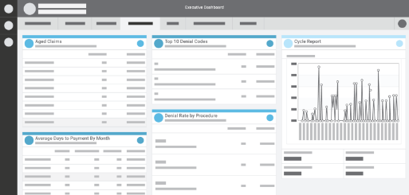

We complete edits on the practice management system prior to claims being staged to claims scrubber applications. Automated claims editing to ensure that the claim data is accurate & will ensure manual edits as needed. We review the all claims rejected from the clearing house systems & resolve them manually & resubmit those claims within 24 hours.

We will run the payer rejection report every day & work on rejected claims & refile them by fixing errors.

**Insurance Eligibility & Benefits Verification & Prior Authorization Services**

Benefits Verification & Prior Authorization Picture



Our staff have excellent knowledge on Payer portals & insurance calling as we have average 10 years of experience & practical knowledge in Insurance Eligibility & Benefits Verification and Prior Authorization Services. We are committed & will ensure that patient insurance eligibility & benefits are completed before patient comes for Doctors consultation & will provide you eligibility & benefits details along with Deductible, Coinsurance & Co Pay by creating cost estimation so that front end staff can collect these charges upfront which increases your practice cash flow & revenue significantly.

**Payment Posting Services**

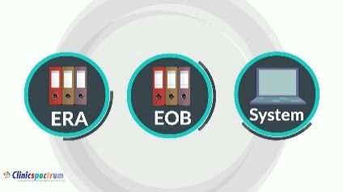

Our dedicated payment posting team will reconcile patient payments such as cash, check & credit card payments along with patient deductibles, co insurces & co – Pay will apply to patient claim/account.

Insurance Posting: Electronic Remittance Advisory. We receive high volume ERAs from payers and process them in batches by importing them into the client’s practice management system. Each batch run throws exceptions that fall out, and we correct the same along with verification of batch totals.

Manual Posting: Our clients often send us scanned EOBs. Each EOB batch is accessed via secure FTPs or through the EHR system and processed in line with the client’s business rules for adjustments, write-offs, and balance transfer to secondary insurance companies or the patients. We understand the payer-specific denial codes for most payers and have expertise in understanding ANSI standard denial codes. We record each claim denial in the practice management system and take actions to re-bill to the secondary insurance company, transfer the balance to the patient, write-off the amount, or send the claim for reprocessing.

**Accounts Receivable & Denial Management Services**

Denial Management Picture



We strive to maintain account Receivable denials less than 8%, our professional & well trained AR callers will We work on multiple contact channels with insurance companies – Website, fax, IVR, and Phone to get an accurate understanding of the claims' status & work the claims towards resolution in first & second touch.

Our work does not end with merely obtaining the status of the claims. We go one step further and initiate the actions such as refiling of these claims and appeals to receive reimbursements, and perform analytics with a focus on reducing the days in A/R. We track & follow up on the claims timely manner, identify the denial issues & fix them, refile the claim as & when needed & work the claims towards resolutions.

**Credit Balance Services**



Refunding Credit Balances

Patient Credit Balance. We analyse each patient's account, identify and validate credit balances, and initiate refund checks to zero out the account balance.

Credit Balance with Payers. Providers should process refunds within 60 days from the date of the refund request. We validate each request, and if found to be valid, we process the refund. If the refund request is invalid, we raise an appeal after thorough validation.

**Patient Statement Services**



We provide comprehensive patient statement services. We generate patient statements every 15 days to ensure electronic statements & printed statements are mailed to patient address on record & timely follow up is done & work with provider to collect the patient responsibility charges.

**Provider Credentialing and Enrollment Services**



**Reliant Global Healthcare Support you for every stage of your revenue cycle Management**

Whether you’re a small independent practice or a large, complex healthcare organization, Reliant Global Healthcare has the technology and expertise to optimize your revenue cycle. Our diverse portfolio of cloud-based and hosted products and services can help you drive efficiency from patient registration right through performance reporting.

Knowing your organization is continuously evolving to meet tomorrow’s challenges, we’ve made our technology flexible. As you grow, consolidate, and change, our products and services scale to match those needs and help you reach your goals along the way.

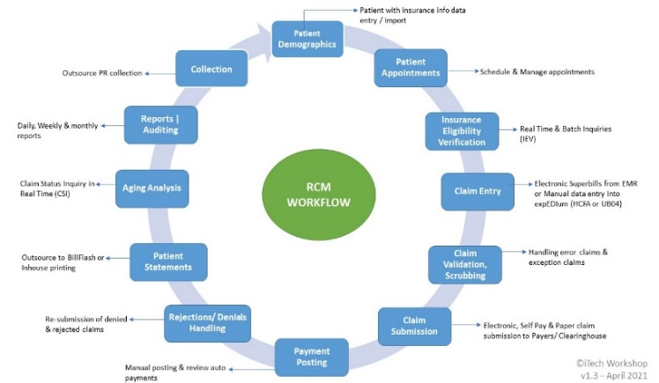

**Reliant Global Healthcare will provide & manage provider’s end to end Credentialing and Enrolments Services.**

**Starting or joining a new practice,**

**Switching from one physician practice group to another**

**Join or become affiliated to new groups or practices**

**Enrol with new payers**

**Maintain their credentialing services**

**Provider Credentialing and Enrolment Picture**

**Use below picture for first home page**

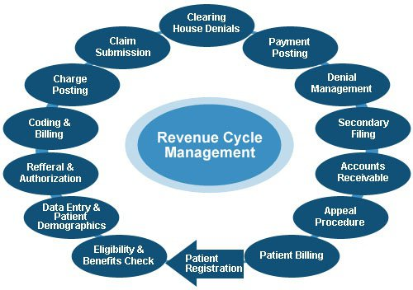

**Products**

**Patient Access Services**

**Medical Coding Services**

**Account Receivables & Denial Management Services**

**Payment Posting Services**

**Patient Access Services**



Reliant Global Healthcare provides complete end to end patient access services such as scheduling Patients appointments, verifying Insurance eligibility and benefits coverage along with creating patient cost estimation for co-payment, Co-insurance and deductible before patient comes for consultations. We help our providers to collect 15% revenue at the front desk and support practice to manage and achieve their operation costs.

We also verify prior authorization requirements for specific CPT codes/services & obtain the authorization through payer portals / insurance calling and ensure that accurate authorizations details are obtained before claim is billed and submitted insurance to avoid denials.

**Reliant Global Healthcare provides critical front-end revenue cycle services and ensures our providers gets below benefits.**

Improved utilization of physician’s time

Reduction of patient no-shows

Improved determination of patient’s payment history, outstanding payments and patient’s coverage for services sought

Improving reimbursement

reducing costs

Improved patient engagement and Satisfaction

Reduction of long waiting times at the front office

**Medical Coding Services**

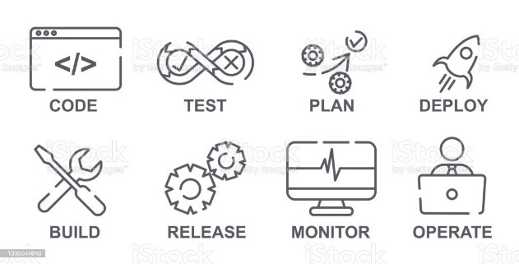

Accurate Medical coding is a critical factor in obtaining reimbursements from Payers as well as maintaining patient records. Coding claims accurately let the insurance payer know the illness or injury of the patient and the method of treatment and enables them to adjudicate claims correctly.

**Overview of Medical Coding Systems and Standards**

Medical coding can involve one or more of the following types of codes: ICD codes, CPT codes, HCPCS codes, DRG codes, and modifiers. All of these coding sets are important for communication and billing purposes. Not only is coding important for capture of details of diseases and creation of medical records but is also important for getting reimbursements from commercial payers as well as Medicare and Medicaid.

**Reliant Global Healthcare** operates a coding center of excellence with certified coders who are proficient in multiple types of medical codes including:

**ICD Codes**. The International Statistical Classification of Diseases or ICD codes is specific to classifications of diagnoses, symptoms, and causes of death in humans. The World Health Organization creates, copyrights, and oversees these classifications. These codes are a global standard and are recognized by every medical facility and practitioner worldwide.

**CPT Codes.** CPT codes or Common Procedure Terminology is defined for every medical procedure and are maintained by the American Medical Association

**HCPCS Codes**. The HCPCS (Healthcare Common Procedure Coding System) levels I and II is another coding system. HCPCS codes are defined in three levels. Level I is comprised of CPT codes, and Level II includes alphanumeric codes that are used to identify products, supplies, and services not included in the CPT codes when used outside a physician's office.

**Level I CPT** (Current Procedural Terminology) codes are made up of 5 digit numbers. These Codes are managed by the American Medical Association (AMA). CPT codes are used to identify medical services and procedures ordered by physicians or other licensed professionals.

**Level II HCPCS** are alphanumeric codes consisting of one alphabetical letter followed by four numbers. These codes are managed by The Centers for Medicare and Medicaid Services (CMS). These codes identify non-physician services such as ambulance services, durable medical equipment, and pharmacy.

**Level III HCPCS codes** are alphanumeric codes W, X, Y, or Z followed by a four-digit numeric code. These are known as local codes, these codes are used as a miscellaneous code when there is no level I or level II code to identify it.

**Modifiers**. Modifiers, a two-digit character set - two numbers, two-letter, or alphanumeric characters, that provide additional information along with HCPCS Codes.

**DRG Codes**. Diagnosis-Related Grouping (DRG) codes are used for coding of inpatient claims. The DRG codes define the accuracy of all the inpatient service components used by the facility. As these groupings are logical, most insurance companies pay according to the DRG used and, therefore, critical for inpatient facilities to obtain proper reimbursements.

**Account Receivables & Denial Management Services**

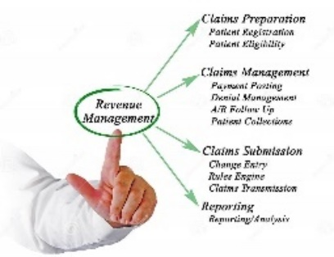

With a full suite of services to manage payments and learn about our deep industry expertise, technology, and process knowledge that helps you get paid faster and more.

Reliant Global Healthcare Back-end Revenue Cycle Management involves collection and management of revenue from the back office. The cycle starts after the provider has conducted a patient visit and we have performed clinical documentation and coding responsibilities, and submitted the claim. Our team includes experienced payment posters and accounts receivable and denial management professionals,

A/R and Denial Management

A/R Follow-up calls

Denials - issue identification, appeals and follow-up

Continuous process improvement by providing feedback to the front-end processes

Credit Balance

Compliant processing of credit balances

Patient and Insurance credit balance processing

Accounts Receivable follow-up process involves the pursuit of an outstanding claim to ensure that the healthcare provider receives payments for the services rendered. This requires the investigation of where the claim is in the cycle, get the correct status of the claim and taking steps to ensure that the claim is adjudicated and paid.

**Our expertise and best practices in Accounts Receivable Follow-up**

We help our clients recover more money through a structured process that involves:

Sorting of Claims to prioritize Accounts Receivable follow-up

Sort by balance due(highest to lowest) and clubbing them into buckets such as $3,000+, $2,000–2,999, $1000–1,999, $500–999, $100–499, $50–99, $10–49

Sorting by Ageing buckets – 120+ days, 90-119, 60-89, 30-59, and current

Sort by payer type

Sort by date of service and date of claims submitted

Ensure Timely Account Follow-Up and strive to keep as many accounts current as possible

We follow-up on all open claims to ensure that each claim is addressed

We organize our teams by Payer to help them understand and develop payer-specific follow-up strategies and build relationships with the payer team

Routinely, we initiate feedback on denial trends to the front end to prevent denials from occurring

With more and more payers providing claims status online, we improve physician adoption of online services by creating logins for the physician and utilizing it both for A/R status as well as for eligibility verification, where available.

Post submission of claims to the healthcare payer, one of the four events could occur:

**Claimed amounts are paid appropriately.** This is the ideal case for the healthcare providers that they receive the expected level of reimbursement.

**Incorrectly paid claims**. Incorrect payments could be on account of over-payments or under-payments. Over-payments need to be repaid to the insurance companies (credit balances) and underpaid claims require an analysis of the cause of the underpayment and appeal back to the payer to adjudicate it correctly.

**Denied Claims.** Claim denials can happen on account of a variety of cases and hence the denial management staff should determine where the error has occurred, fix the error and appeal the claim.

**Unpaid Claims**. Claims may remain unpaid on account of incorrect insurance information of the patient, delays at the payer end (lost claims), inaccurate patient information, or claim being held by the payer. These open claims should be actively pursued, appropriate status obtained, and resolution of the issue to get the claim back into the adjudication cycle.

Reliant Global Healthcare brings energetic team members who have the knowledge of the reimbursement processes, exercise highly diligent and streamlined process to ensure that our clients are able to maximize reimbursement.

**Payment Posting Services**



Reliant Global Healthcare offers market-leading SLAs for accurate and timely payment posting services. Our well-defined payment posting process not only ensures efficient processing but also helps you identify opportunities to increase revenue by watching for trends of payments, and denials. Our services include the following components to make your billing process more efficient and lead to an improvement in revenue.

**EOB and ERA posting and reconcilement**– We meticulously capture the data from EOBs, lockboxes, and ERAs, ensuring a high degree of accuracy of payments posted on the revenue cycle system.

**Denial prevention -**We examine each denial to identify issues such as denial for medical necessity, non-covered services and prior authorization to provide constructive feedback to the entire chain of physicians, front office staff, billers and coders to avoid such errors in the billing cycle and improve reimbursements.

**Denials posting and reworking -** We rework each denial and resubmit the claim to responsible payers in an efficient manner to enable recovery of as much reimbursement due as possible

**Patient responsibility for Payment -**Patient dues are identified and the balances are moved to patient responsibility to ensure faster patient billing and initiation of the patient collections cycle.

**Write-offs and adjustments**– We process write-offs, adjustments and look into contractual adjustments and passing them to management when issues are identified. We work with the provider’s office to help develop the write-offs and adjustments policies to ensure that the accounts receivable data shows the right view to the management. Often, practices with ineffective write-off and adjustment policies have erroneously inflated A/R views and such situations can be avoided through effective policies

**In-person collection issues** – Front offices of the provider’s office make mistakes with the collection of deductibles and/or co-payments when processing insurance remittances and this has a major impact on the overall billing process. Through Reliant Global Healthcare’s best practices in identifying these issues, the front-office gets constant feedback on missed opportunities which leads to behavioural corrections at the front-office.

Better cash flow, better collections, faster identification of issues and resolution of these issues across the chain, these are some of the value propositions that Reliant Global Healthcare’s payment posting services offer. Secondary billing effectiveness and initiation of patient collections processes ensure that the entire medical billing process runs effectively.

aktiv-grotesk

**Our Story**

**The Genesis of Reliant Global Healthcare**

**From Idea to Reality: Our Journey**

With 20 years of US corporate experience, 18 of which have been with US-based healthcare revenue cycle and India-based BPO/KPO companies, Ningaraju is backed by strong leadership and management experience in start-ups and M&A. The first 11 years of his career were spent at AXA Healthcare, worked in US & India & handled both onshore & offshore operations and then Ningaraju followed his entrepreneurial spirit in 2022 when he became Founder/CEO of a US medical billing company.

Ningaraju decided that building successful BPO/KPO offshore operations to bring about cost reduction and improved turnaround times for US clients was the better approach hence he started Reliant Global Healthcare. Also, by having previously run large-scale medical billing operations in the US, Ningaraju clearly understands the needs of today’s US healthcare and revenue cycle management companies and the forces affecting their businesses.

His previous experience includes several senior roles at Genpact India Pvt Ltd & Access Healthcare Pvt Ltd where he spent years building, scaling, and nurturing multiple businesses that served clients globally. He was in charge of digital operations, which he scaled and transformed to be technology-driven, using intelligent process automation and platforms with a significant focus on healthcare and big tech clients.

Switching to Reliant Global Healthcare for our medical billing was seamless. Their team guided us through the process and ensured that our revenue cycle was unaffected. Their expertise made the transition a breeze.

In the world of medical billing, accuracy and efficiency are paramount. Reliant Global Healthcare has excelled in both aspects, streamlining our billing processes and maximizing our revenue. Their expert team is a pleasure to work with.

Choosing Reliant Global Healthcare was one of the best decisions we made for our practice. Their professionalism and dedication to precise billing have given us confidence in our financial management. They're more than just a billing service; they're our trusted partners.

Partnering with Reliant Global Healthcare has been a game-changer. They've taken our billing management to a whole new level, providing accurate, efficient, and reliable services. We consider them an invaluable part of our team.

**Schedule an Appointment with Our Medical Billing Experts**

At Reliant Global Healthcare, we are dedicated to providing you with personalized and efficient medical billing solutions. Whether you're a healthcare provider seeking assistance or have questions about our services, we're here to help. Schedule an appointment with our experts to discuss your billing needs and explore how we can optimize your revenue cycle management.

Increasing healthcare costs, advancement of technology, and evolving patient-physician-hospital dynamics are forcing healthcare industry to reorganize their business delivery processes. In order to maximize value from their business processes, global healthcare companies are leveraging the healthcare business process outsourcing model.

One of the key players helping global healthcare organizations meet their cost disparity is Outsource2india. Our focus is not just on reducing the costs for our clients, but increasing their business revenue. By offering our services, we not only help our clients shrink A/R, adjudicate claims, and post accurate payments, but also ensure up to 90% collections which results in a 20% improvement in their cash flow.

* **Charge entry Specialist $1200 to 1400 USD**
* **Medical Billing Support**- **$1280** to **$1440** per biller per month
* **Medical Coder**- **1600 USD** per Coder per month
* **AR Caller** - **1440 USD** per FTE per month
* **Demography Data entry**- **1280 USD** per FTE per month